Git Hub Link:
https://github.com/adepurithesh/Retail-Capstone-Project/tree/main/Retail

- Created Bronze, Silver and Gold Tables:
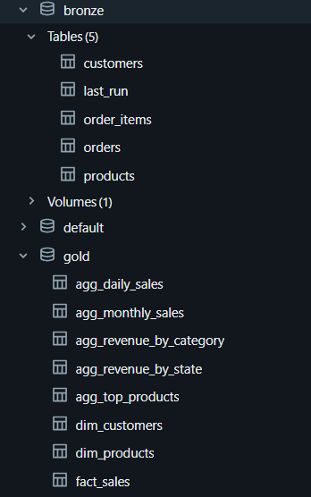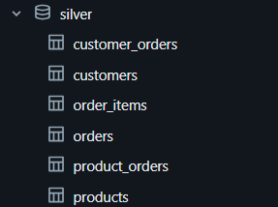
- Implemented the Incremental data loading using the merge into statements in the silver and gold tables
Sample Query: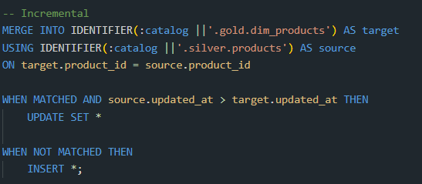
- Optimised the spark jobs by using the catalog variable to run the bronze, silver and gold notebooks in dev and prod catalogs.
Dev Job
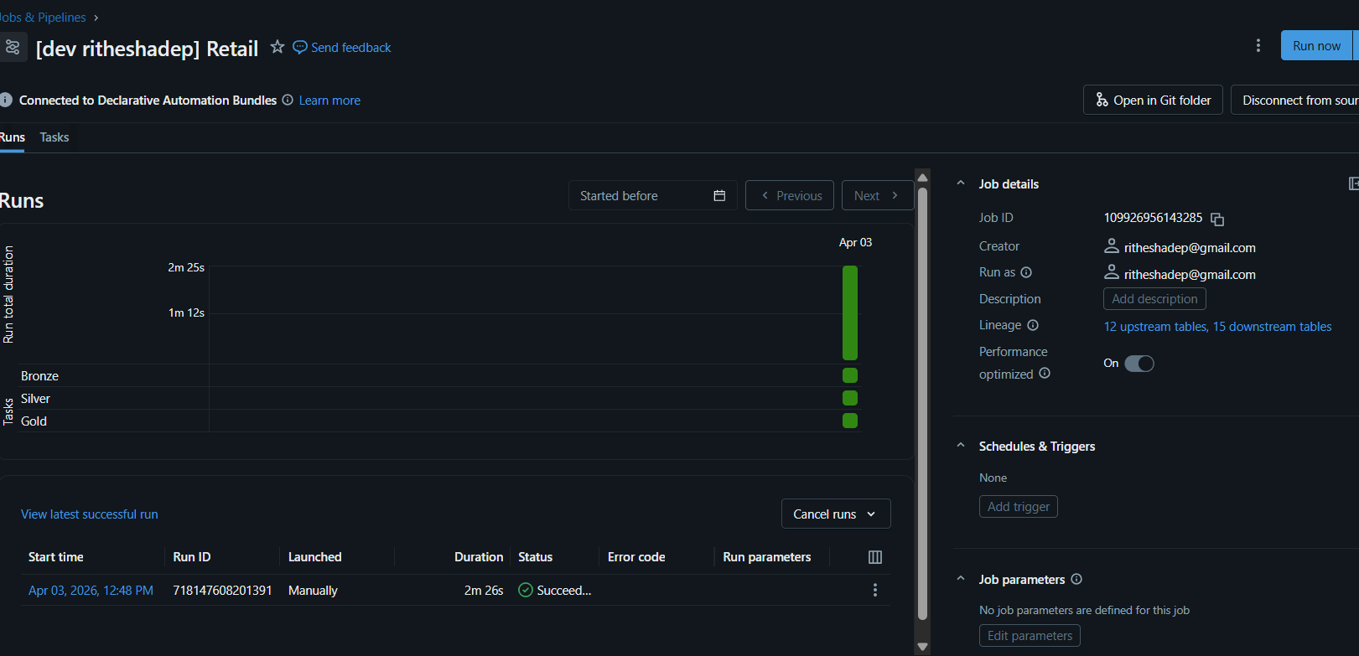
Prod Job
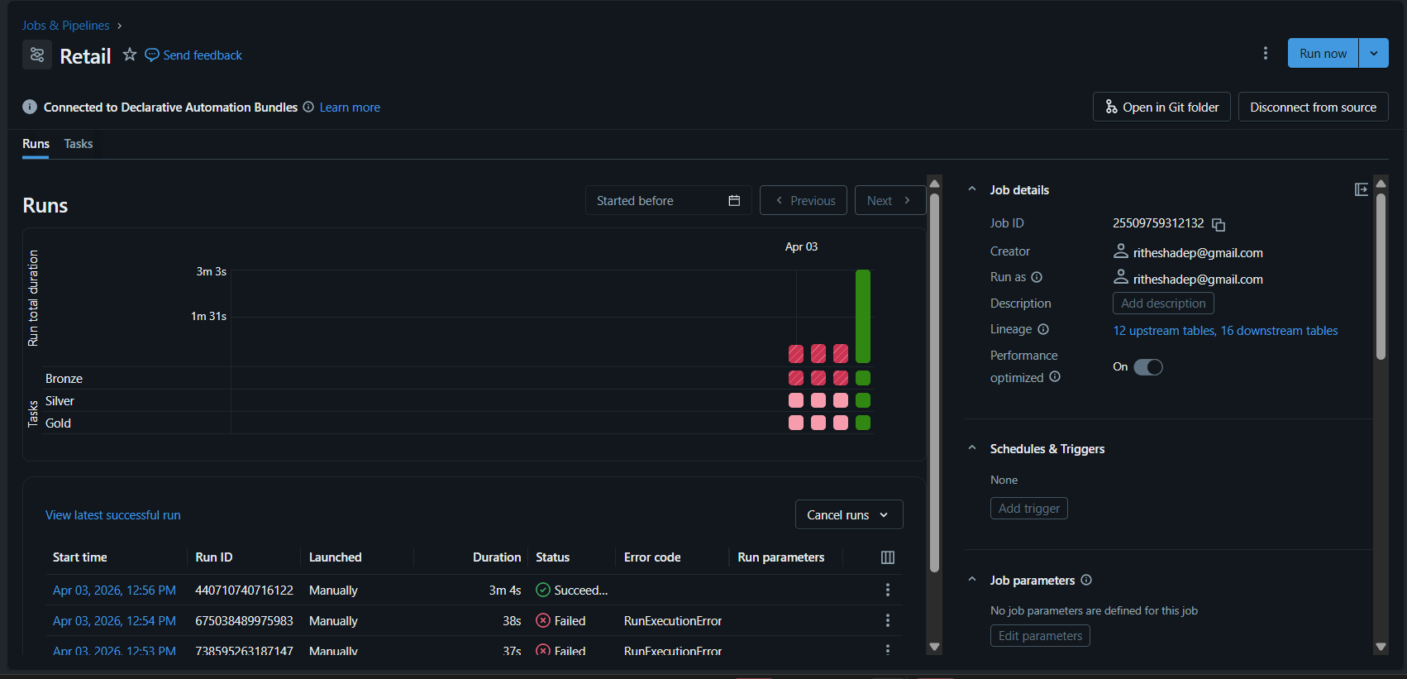
- Delta Optimization Scripts:
- Broadcast Join Our customers and products tables have around 50K records each which is small enough to fit in memory. When joining with order_items (which can have 500K+ records as multiple items per order), we broadcast customers and products to avoid shuffling the large order_items table across nodes.
- Partitioning Our fact_sales is partitioned by order_month. Since our aggregations like monthly revenue and daily trends always filter by month, Spark skips irrelevant months entirely.

6.DashBoard (sample Screen Shots):
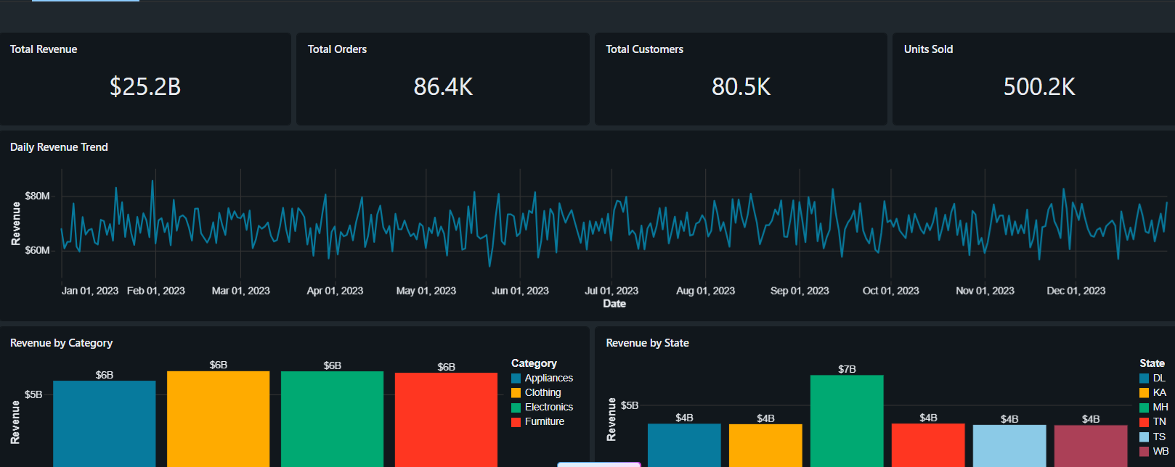
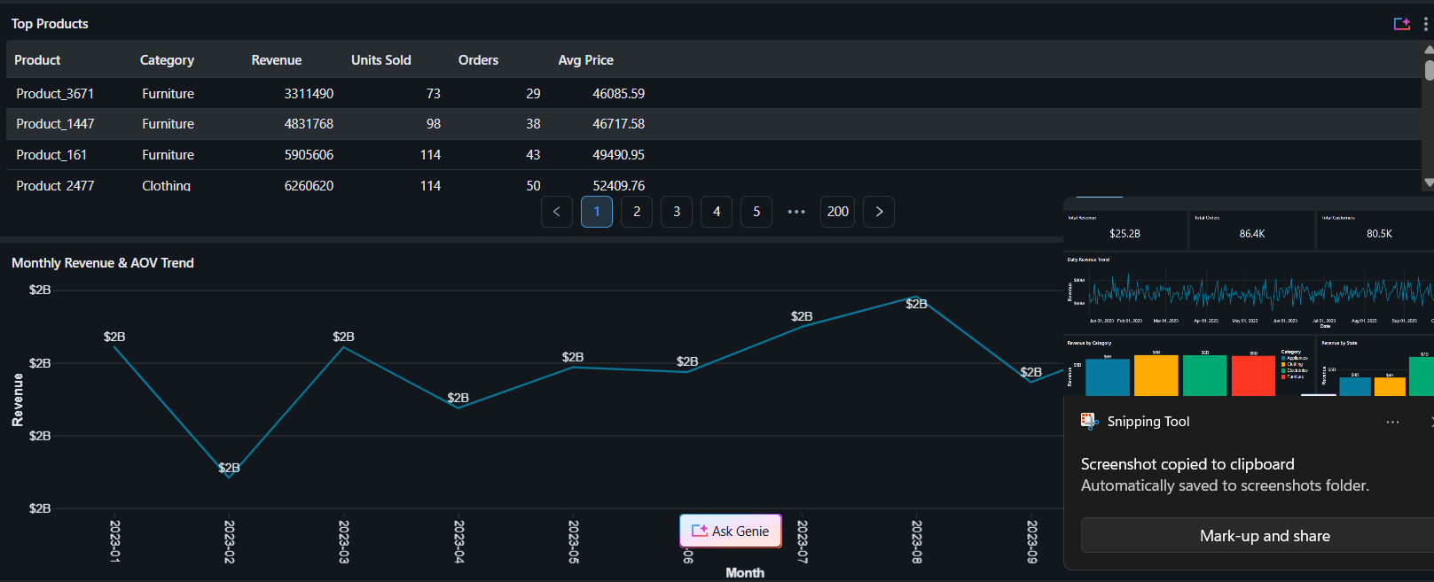
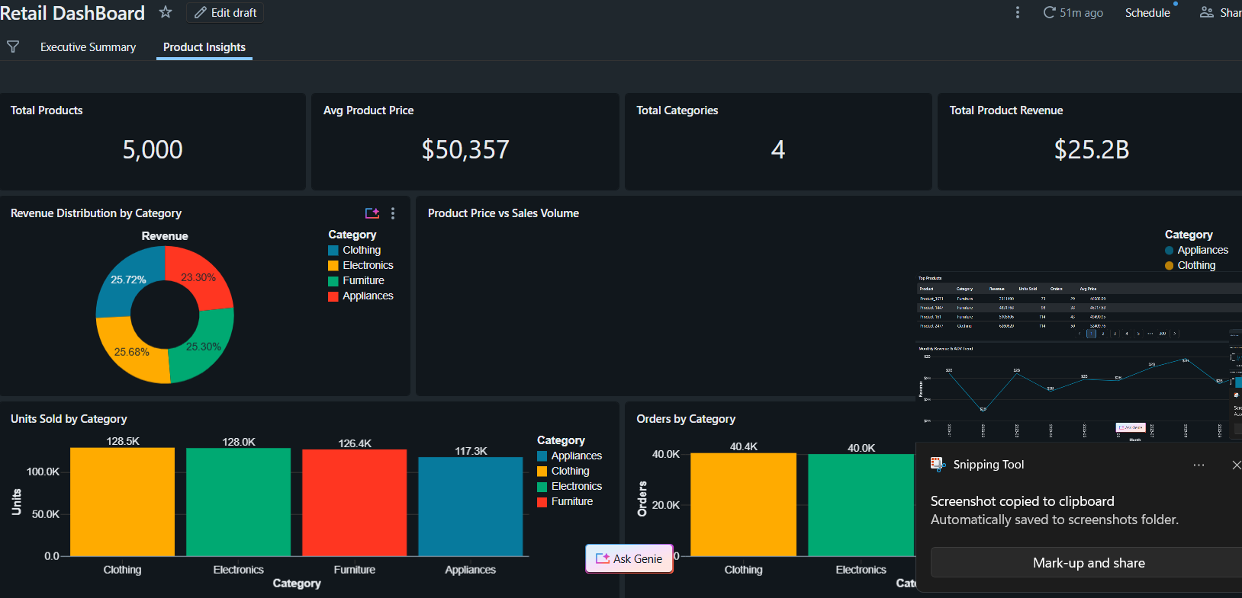

Genie Sample Output
